Glaucoma UK
National Patient
Voices Survey

Campaign toolkit

6 July – 6 September 2026

Introduction
This toolkit is designed to help you easily share and promote the Glaucoma UK National Patient Voices Survey campaign with your organisation and networks.
With your help, we can encourage as many glaucoma patients as possible to complete the survey, ensuring more voices are heard. Every response contributes to the success of the project.

What is the National Patient Voices Survey and why does it matter?

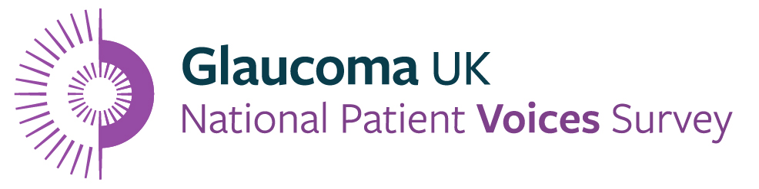
Glaucoma UK’s National Patient Voices Survey is the largest glaucoma patient survey ever carried out in the UK. Running from 6 July to 6 September 2026, it is a chance for everyone with glaucoma to shape the future of glaucoma care in the UK.
The survey aims to hear from around 10,000 people living with the disease, but the more experiences we gather, the louder and clearer our collective voice will be with policymakers and NHS decision-makers.
We want to make sure patients’ experiences influence not just what we do here at Glaucoma UK, but decisions about care across the UK.

When is it?
The National Patient Voices Survey launched on Monday 6 July and will remain open until Sunday 6 September 2026.

Who coordinates it?
The National Patient Voices Survey is coordinated by Glaucoma UK and facilitated by an independent research organisation, the Picker Institute. The campaign is only possible thanks to the thousands of people living with glaucoma who take the time to complete the survey and share their lived experiences, and the professionals and organisations helping us reach them.


How you can help

Hearing from 10,000 people with glaucoma is no small task. Help us reach as many people as possible, by sharing our suggested content in your communication channels. Visit our website, share the link to our survey and order promotional materials – every single action makes a difference.
Share the survey in your organisation’s newsletter
If you’re part of an organisation, such as a local sight-sector charity, that sends a regular email newsletter with a patient audience, please consider sharing the survey with your subscribers. To make this as easy as possible, we’ve prepared some ready-to-use copy you can drop straight into your next email.
Suggested wording:
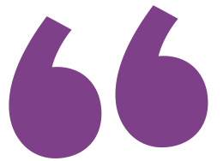
Glaucoma UK is running the UK’s largest-ever survey of people’s experiences of living with glaucoma. If you have glaucoma, or are being monitored for glaucoma, your experience could help shape the future of glaucoma care.
The survey closes on 6 September 2026. Every response will help make sure patients’ voices are heard and reflected in future services.
Complete the survey by visiting glaucoma.uk/voice or request a paper copy by phoning 01233 557 207.

Suggested social media copy and sharing ideas
Our official campaign hashtag is #GlaucomaVoices and we’d love it if you could share the link to our dedicated website page for the campaign: www.glaucoma.uk/voice
Help us spread the word on social media with a post on your preferred platform. Here are some ideas:
Social post one (launch post):
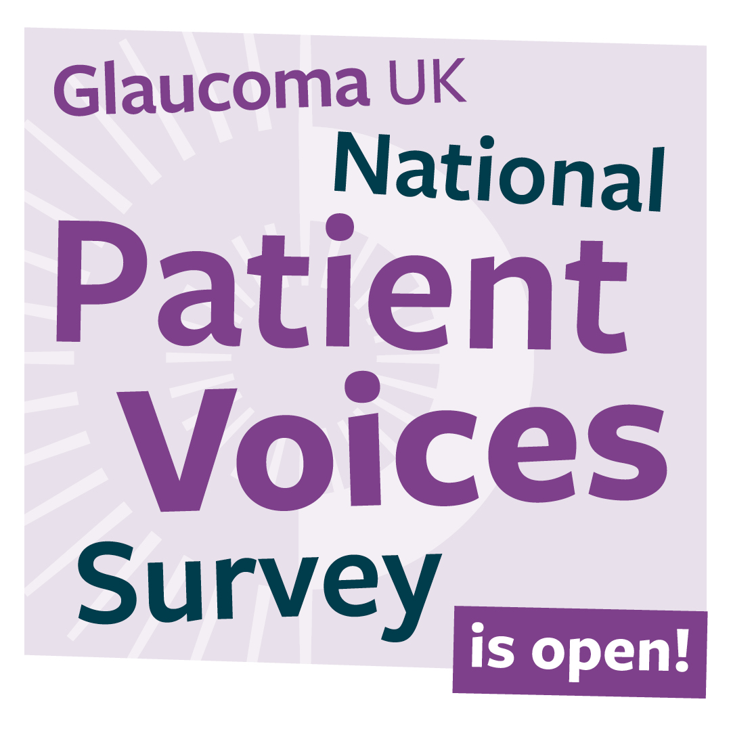
Glaucoma UK’s National Patient Voices Survey is now open!
If you have glaucoma, or are being monitored for glaucoma, this is your opportunity to share your experience and help shape the future of glaucoma care.
No patient voice should go unheard. Together, we can help influence real change for people with glaucoma across the UK.
Everyone’s experience matters, so please complete the survey today: https://glaucoma.uk/national-patient-voices-survey/
#GlaucomaVoices

Social post two:
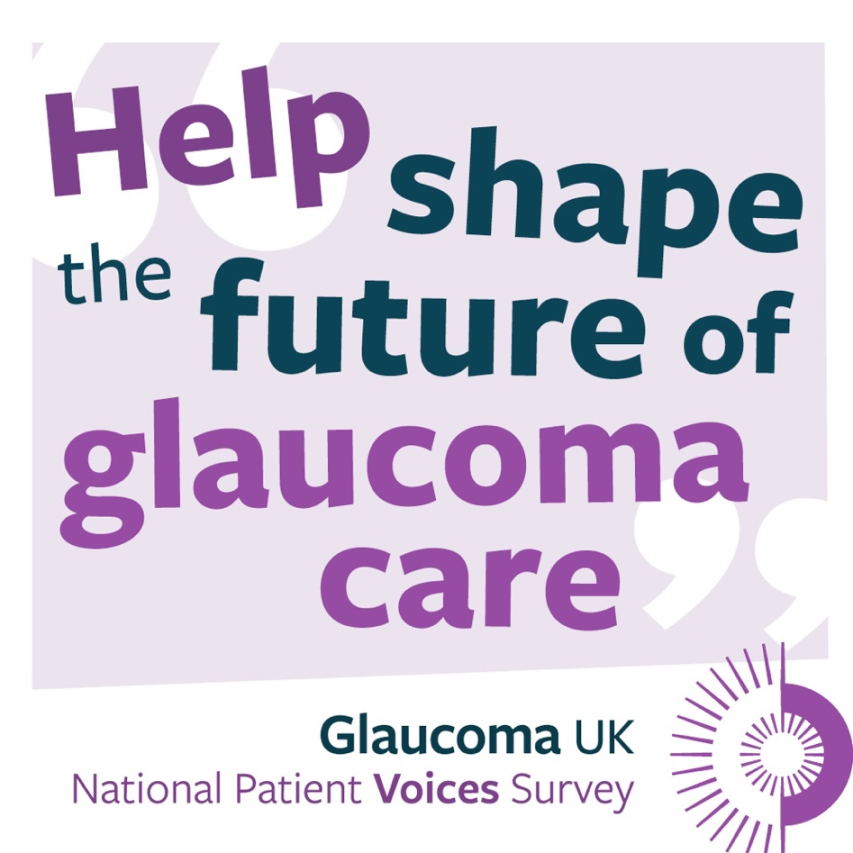
Glaucoma UK’s National Patient Voices Survey is a nationwide effort to understand the real experiences of people living with glaucoma, and to push for better care and support.
By sharing this post, you can help reach more people. Every story and every experience matters – and every insight adds weight.
Visit the Glaucoma UK website to fill out the survey – and please share this post to reach more people affected by glaucoma.
Take the survey now: https://glaucoma.uk/national-patient-voices-survey/
#GlaucomaVoices
Social post three:
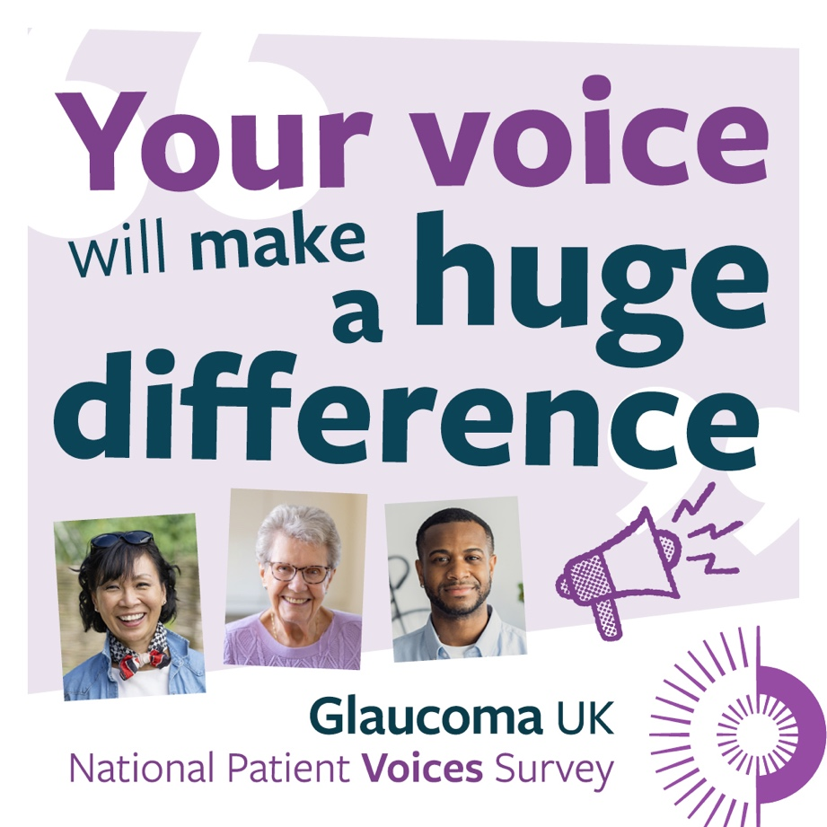
With the right care, at the right time, you can live well with glaucoma. But right now in the UK, this isn’t always the case. Some people struggle to get follow-up appointments. Others worry about medication side effects or have difficulty using eye drops. And for many, the diagnosis and ongoing concerns affect mental health.
Your experiences can help make a case for change.
Add your voice to the Glaucoma UK National Patient Voice Survey. The responses will be shared with those devising policy, making decisions and providing treatment.
If you have or are being monitored for glaucoma, visit https://glaucoma.uk/national-patient-voices-survey/
#GlaucomaVoices
Please ensure you tag our Glaucoma UK social media accounts so we can engage with your posts too!
Find Glaucoma UK on:
- Facebook
- Instagram
- Threads
- LinkedIn
- YouTube
We have a comprehensive social media campaign planned, which will include videos from patients and professionals. Please help us to reach a wide audience by sharing our posts. If you would like to use any of the assets we’ve posted on your own channels, please get in touch with voice@glaucoma.uk and we’ll be happy to help.
Order printed promotional materials
We offer a ready-to-use promotional bundle of printed materials designed to give you everything you need to encourage people to take part in the survey. There are two options available:
The English language bundle includes:
  - 4 A3 posters for display in waiting and clinic areas
  - 300 A5 flyers to hand to patients
  - 300 business card-sized resources for easy takeaway reminders
The English and Welsh language bundle includes:
  - 8 A3 posters (4 in English and 4 in Welsh)
  - 300 double-sided A5 flyers (English on one side, Welsh on the other)
All materials clearly explain how patients can take part and why their voice matters.
These can be ordered directly from our website here.
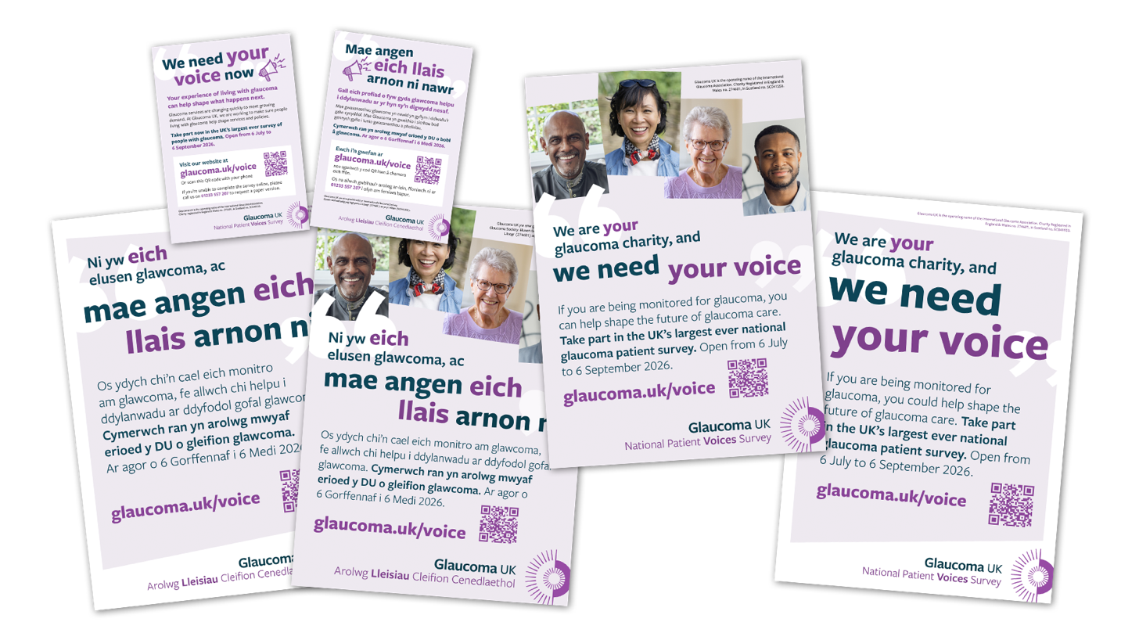

Order printed surveys
Wherever possible, we would like encourage people to complete the survey online here.
However, we recognise that some people may prefer to complete a paper copy for a variety of reasons. If you’d like to order multiple copies of the paper survey please visiting our website here.
If you’d like just one copy, please order one by phoning 01233 557 207 or by emailing voice@glaucoma.uk.
Add a banner to glaucoma patient letters
If you regularly write to people with glaucoma, could you include a survey banner in your letters? We have a ready-made footer graphic with a QR code linking directly to the National Patient Voices Survey.
To request the banner, email voice@glaucoma.uk. If our standard version is not quite right for your needs, we can create a tailored version for you.

Questions and thank you
We're grateful for your help in sharing these free resources and helping us reach a wider audience. If you would like to request something outside of this suite or have any questions about the project, please email us at voice@glaucoma.uk and we’ll try to help.
We also have several assets available in Welsh, please email voice@glaucoma.uk to request these.
Thank you so much for supporting this important project to capture glaucoma patient insights.

